Star Wars website – Server-Side mockups

Felipe .M Iglesias



CONTENT

EXECUTIVE SUMMARY 2

DATABASE CONNECTION 3

PRIVATE SIDE - LOGIN 4

PRIVATE SIDE – CREATE DATA 7

PRIVATE SIDE – UPDATE DATA 10

PRIVATE SIDE – DELETE DATA 12

PUBLIC SIDE – READ DATA 14

PUBLIC SIDE – SORT DATA BY A-Z 16

PUBLIC SIDE – SORT DATA BY Z-A 18

PUBLIC SIDE – SORT DATA BY RECENTLY ADDED 20

PUBLIC SIDE – SORT DATA BY EPISODE 22

# EXECUTIVE SUMMARY

In this document we are going to develop the server-side technical information. We will describe and showcase how to manage the data and resolve the login.

# DATABASE CONNECTION

The function that will handle the database connection will be the following:

In each navigation file this control programming will be implemented:

# PRIVATE SIDE - LOGIN

The user will be able to login using a username and a password stored in the SQL database.

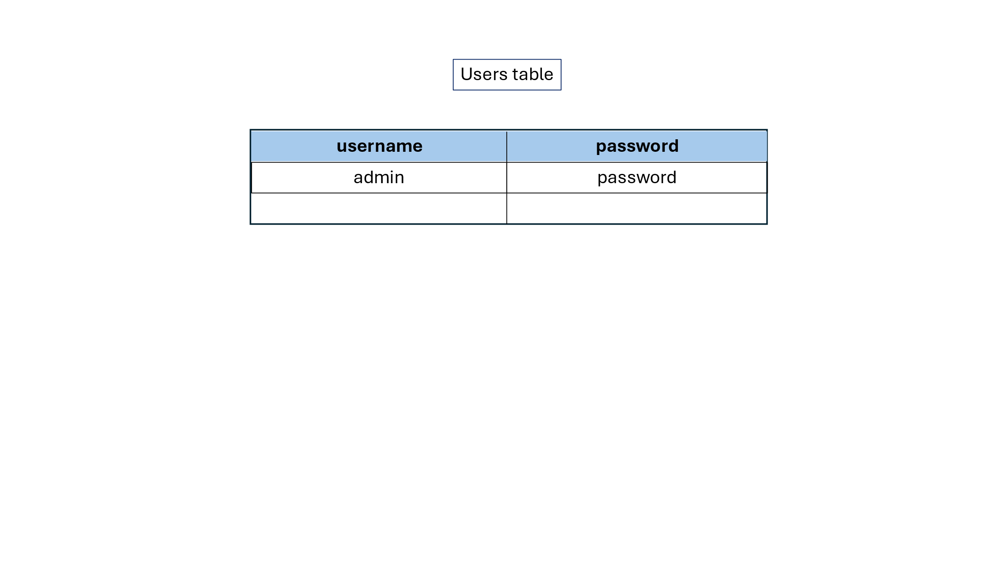

**Data Flow**

Sections

1. Movies summary

2. Characters

3. Ships

4. Planets

5. the force

6. Jedi

7. Sith

8. Alien Races

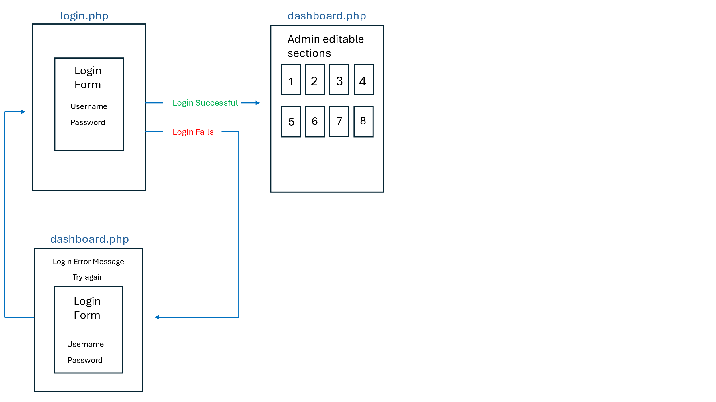

**Functions and Programming Control**

Once the user arrives at the login section he will be asked to insert his credentials. Then, the following function will look and compared the entered data with the data stored in the database.

functions.php

The information entered by the user at login.php will be sent as POST to dashboard.php, once there the programming control will be used to check that the parameters are correct and allow the navigation trough the private side.

login.php

dashboard.php

logout.php

# PRIVATE SIDE – CREATE DATA

Once the admin is authenticated, he will have the capability to create new records for each section. This example will be made with the **ships section** (number 3).

*All sections will have the same data flow and behaviour.*

**Data Flow**

Sections

1. Movies summary

2. Characters

3. Ships

4. Planets

5. the force

6. Jedi

7. Sith

8. Alien Races

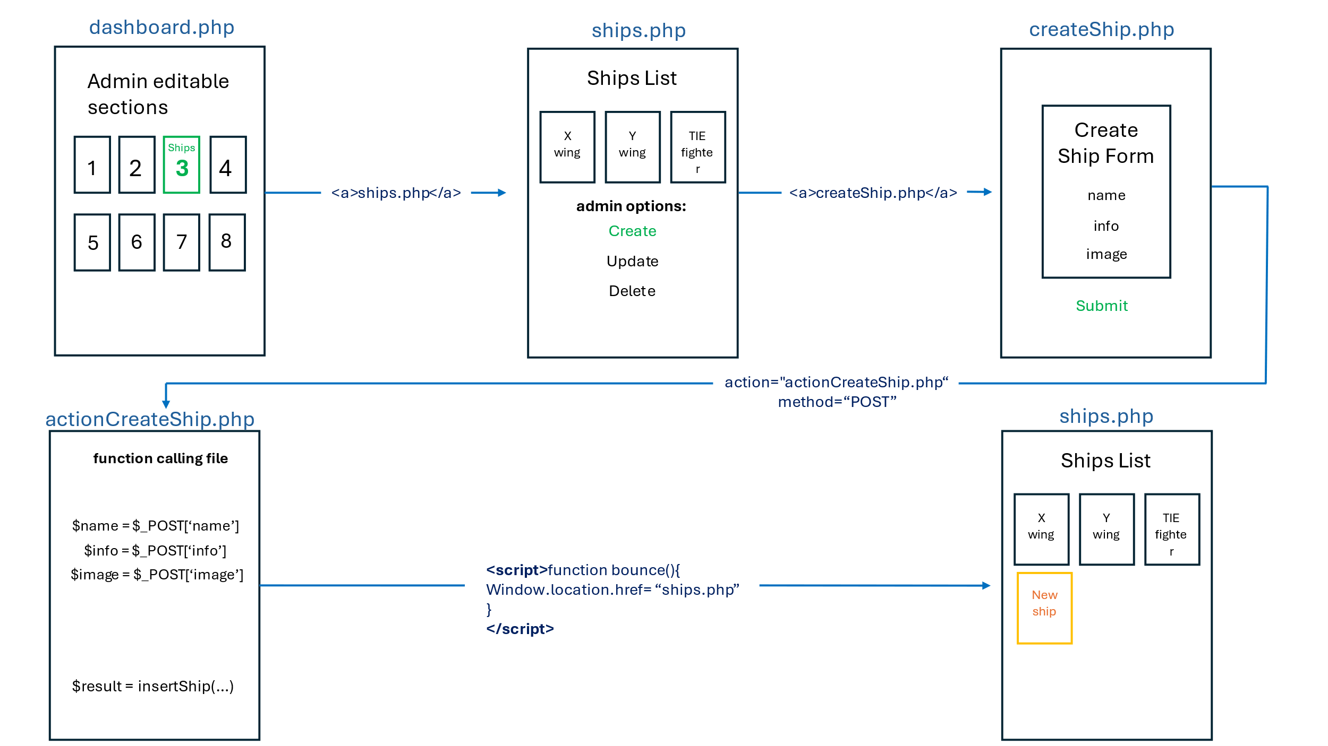

**Functions**

When selecting the section to create the new record, the admin will be redirected to createShip.php. Once there, he fills the form to add the new record. Next, the information provided by the admin will be sent to actionCreate.php to be added to the database. Once this process is over, a bouncing script will redirect the admin to the ships.php where he can see that the new record was successful added.

functions.php

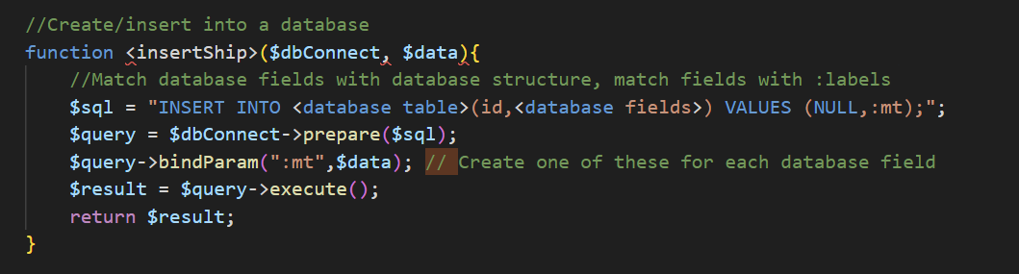

ships.php

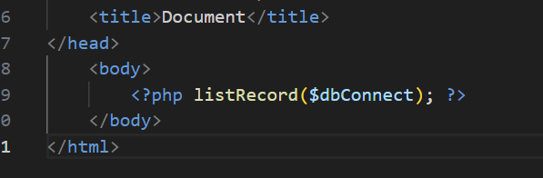

createShip.php

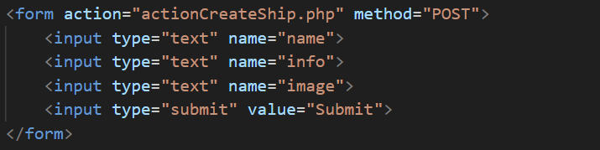

actionCreateShip.php

# PRIVATE SIDE – UPDATE DATA

Once the admin is authenticated, he will have the capability to update records in each section. This example will be made with the **ships section** (number 3).

*All sections will have the same data flow and behaviour.*

**Data Flow**

Sections

1. Movies summary

2. Characters

3. Ships

4. Planets

5. the force

6. Jedi

7. Sith

8. Alien Races

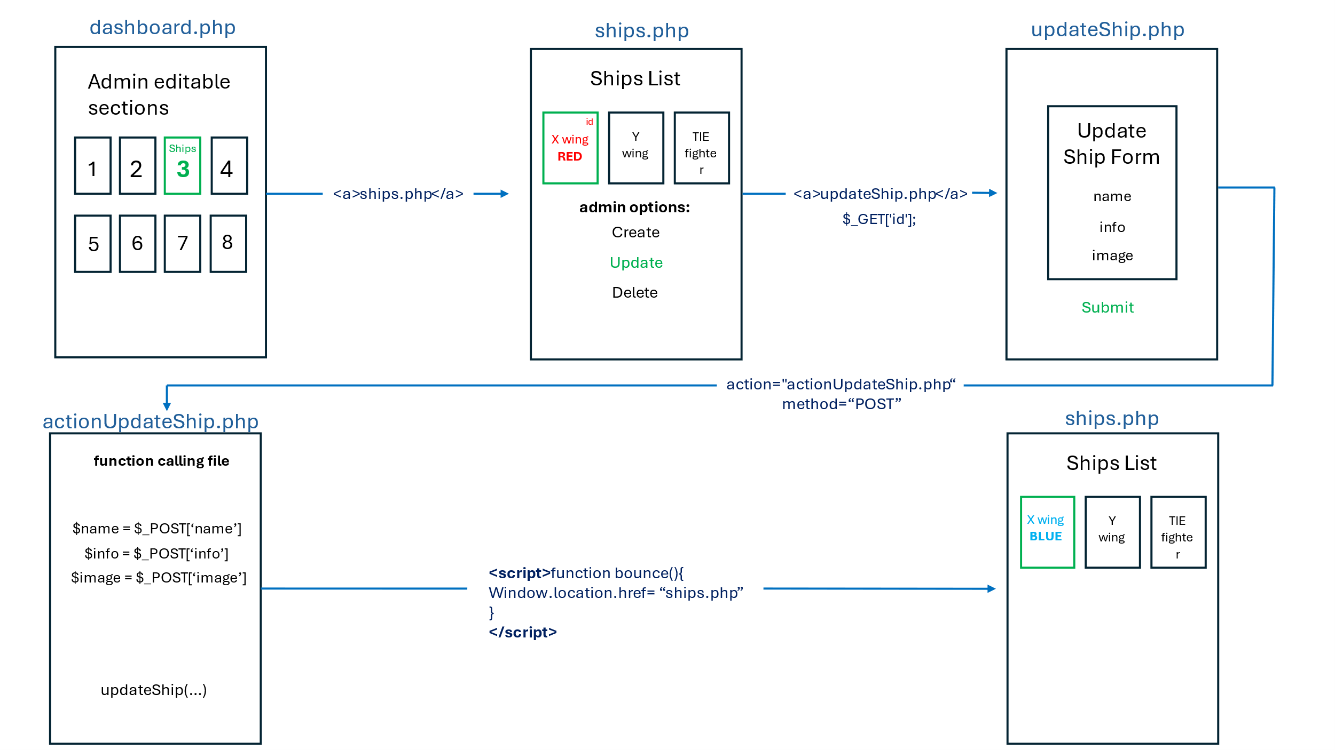

**Functions**

The admin will click on the record he wants to update from the ships.php file. The id of the selected record will be stored in the GET memory. From here, he will be redirected to the updateSection.php. At this point will fill a <form> with the updated data and send it to actionUpdateShip.php via POST. Here the update function will be called and make the changes in the database.

functions.php

updateShip.php

actionUpdateShip.php

# PRIVATE SIDE – DELETE DATA

Once the admin is authenticated, he will have the capability to delete records in each section. This example will be made with the **ships section** (number 3).

*All sections will have the same data flow and behaviour.*

**Data Flow**

Sections

1. Movies summary

2. Characters

3. Ships

4. Planets

5. the force

6. Jedi

7. Sith

8. Alien Races

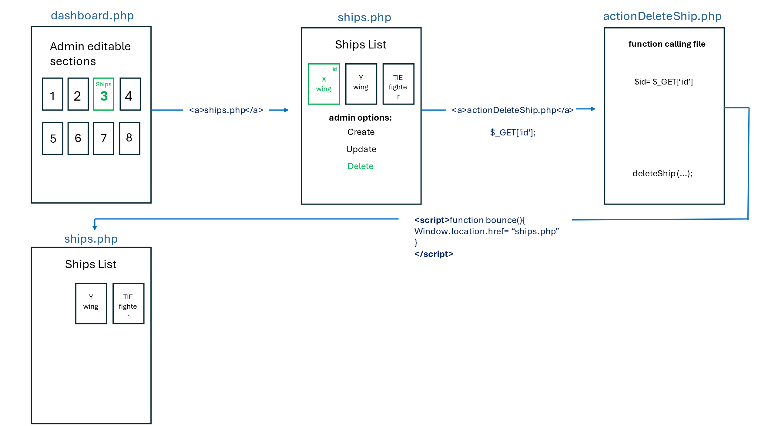

**Functions**

The admin will click on the record he wants to delte from the ships.php file. The id of the selected record will be stored in the GET memory. From here, he will be redirected to the actionDelete.php. Next, the delete function will be activated and the record deleted from the database. Finally, the admin will be automatically redirected to ships.php by the bouncing script.

functions.php

actionDeleteShip.php

# PUBLIC SIDE – READ DATA

The users he will have the capability to read records in each section. This example will be made with the **ships section** (number 3).

*All sections will have the same data flow and behaviour.*

**Table**

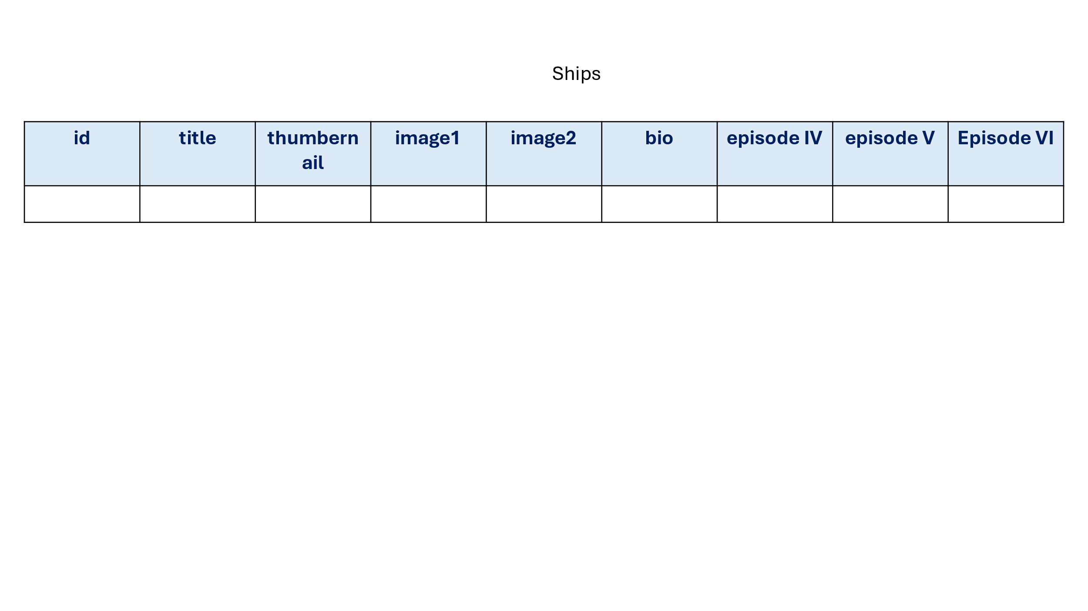

**Data Flow**

Sections

1. Movies summary

2. Characters

3. Ships

4. Planets

5. the force

6. Jedi

7. Sith

8. Alien Races

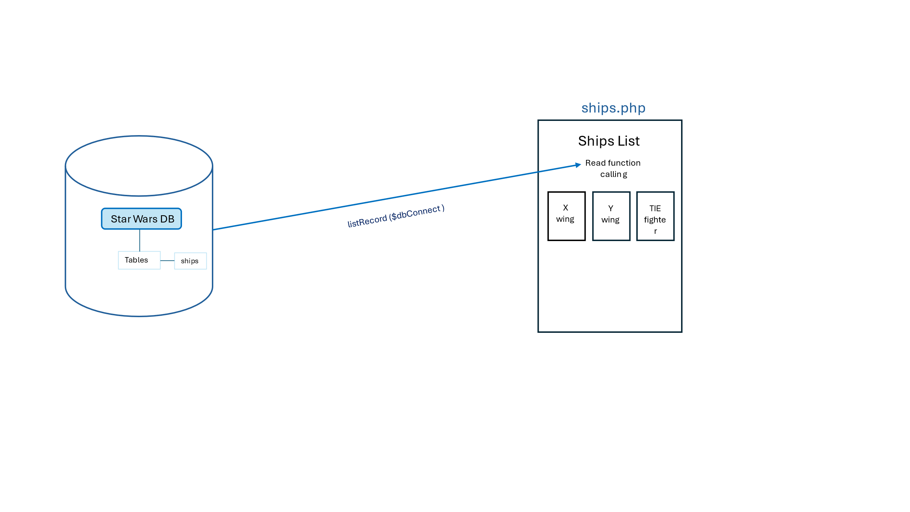

**Functions**

functions.php

ships.php

# PUBLIC SIDE – SORT DATA BY A-Z

The users he will have the capability to sort records by ascending order in each section. This example will be made with the **ships section** (number 3).

*All sections will have the same data flow and behaviour.*

**Data Flow**

Sections

1. Movies summary

2. Characters

3. Ships

4. Planets

5. the force

6. Jedi

7. Sith

8. Alien Races

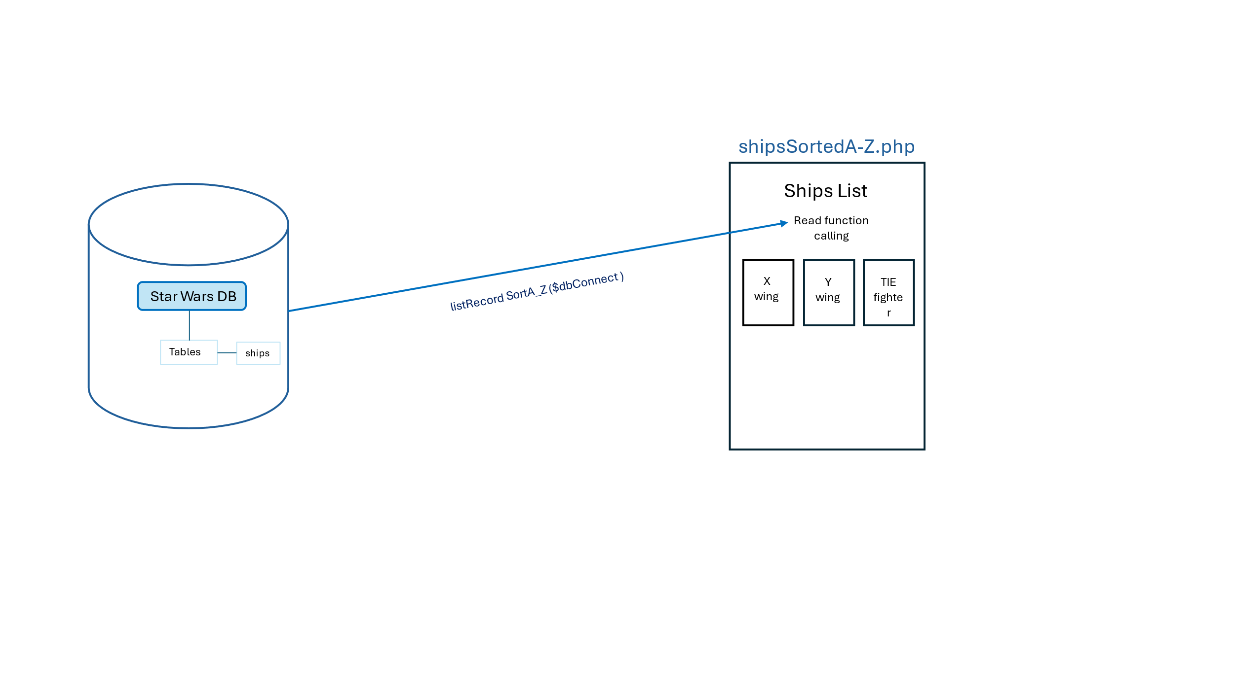

**Functions:**

functions.php

shipsSortedA-Z.php

# PUBLIC SIDE – SORT DATA BY Z-A

The users he will have the capability to sort records by descending order in each section. This example will be made with the **ships section** (number 3).

*All sections will have the same data flow and behaviour.*

**Data Flow**

Sections

1. Movies summary

2. Characters

3. Ships

4. Planets

5. the force

6. Jedi

7. Sith

8. Alien Races

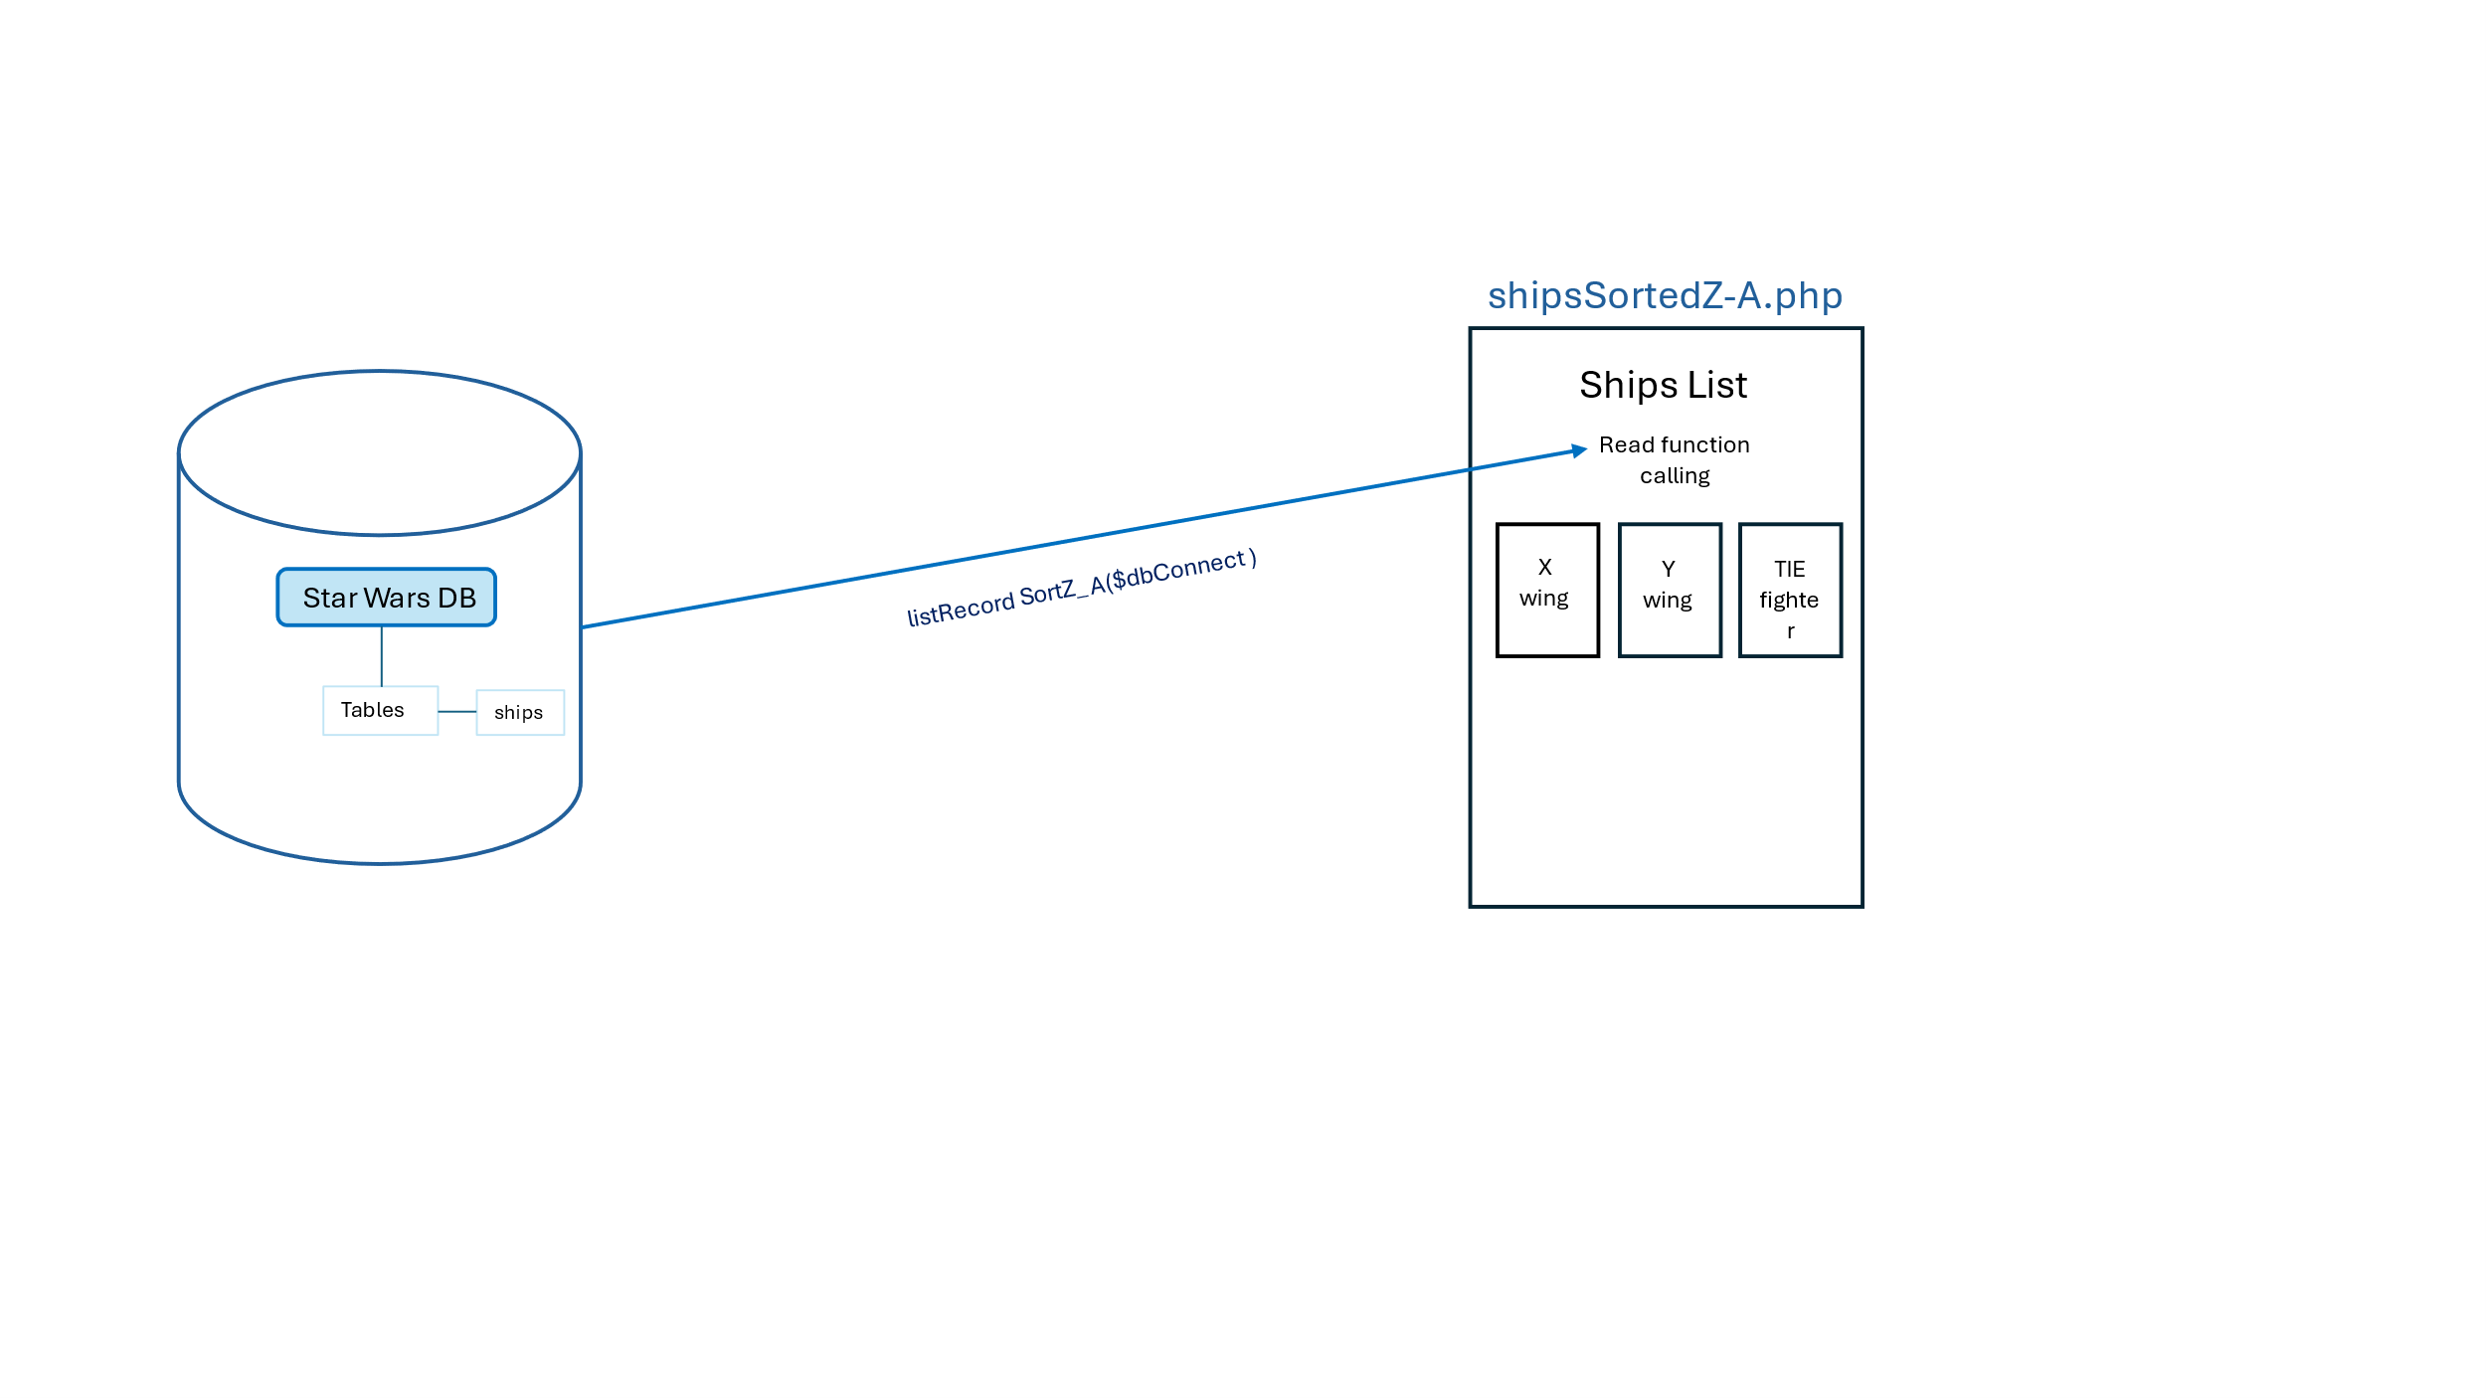

**Functions:**

functions.php

shipsSortedZ-A.php

# PUBLIC SIDE – SORT DATA BY RECENTLY ADDED

The users will have the capability to sort records by recently added order in each section. This example will be made with the **ships section** (number 3).

*All sections will have the same data flow and behaviour.*

**Data Flow**

Sections

1. Movies summary

2. Characters

3. Ships

4. Planets

5. the force

6. Jedi

7. Sith

8. Alien Races

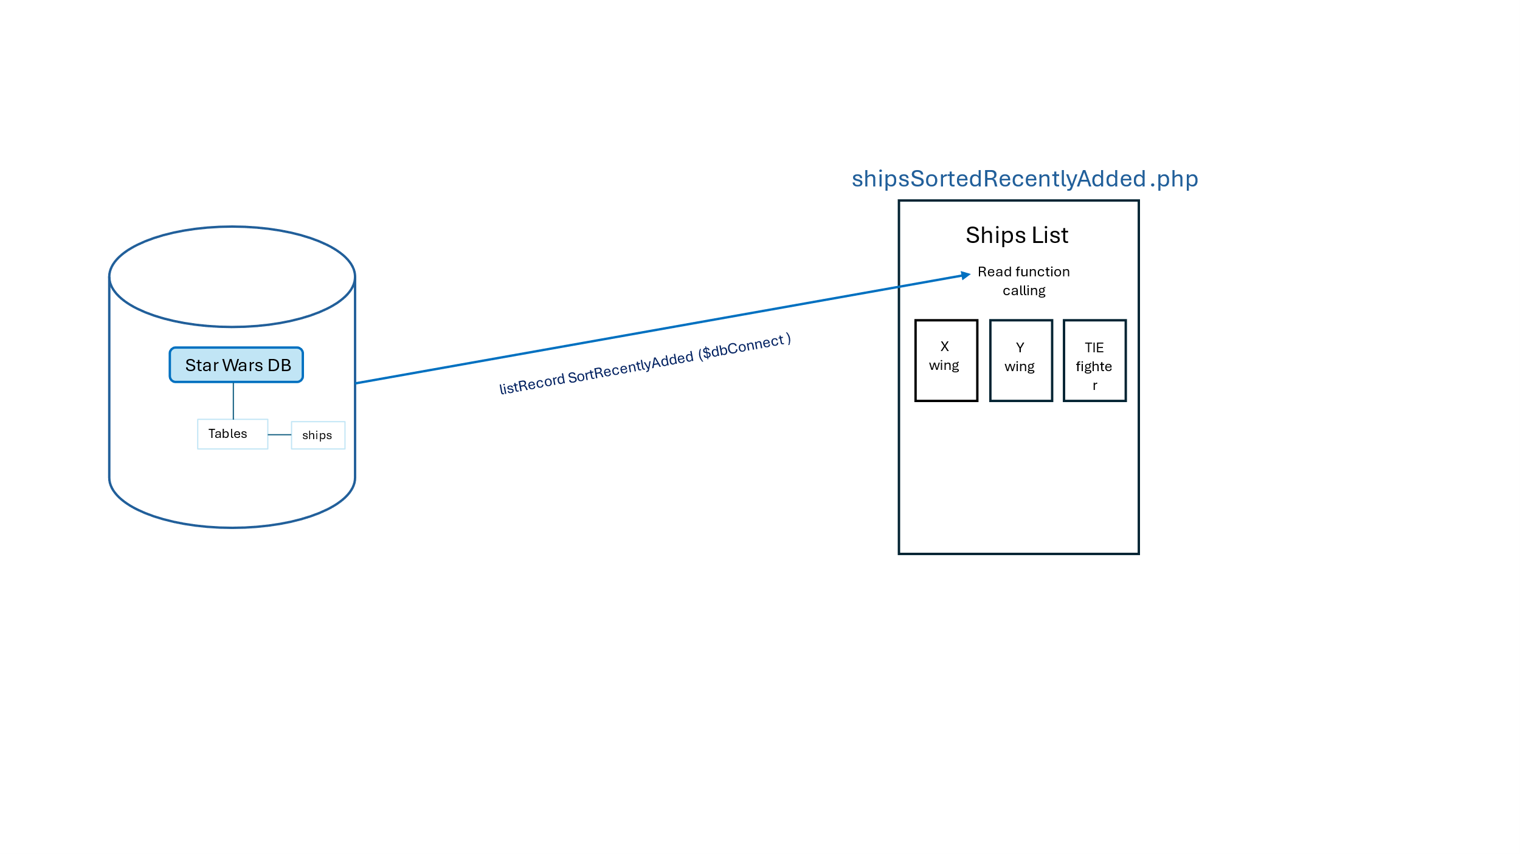

**Functions:**

functions.php

shipsSortedRecentlyAdded.php

# PUBLIC SIDE – SORT DATA BY EPISODE

The users will have the capability to sort records by episode in each section. This example will be made with the **ships section** (number 3) and the episode IV.

*All sections will have the same data flow and behaviour for the episodes V and VI*

**Data Flow**

Sections

1. Movies summary

2. Characters

3. Ships

4. Planets

5. the force

6. Jedi

7. Sith

8. Alien Races

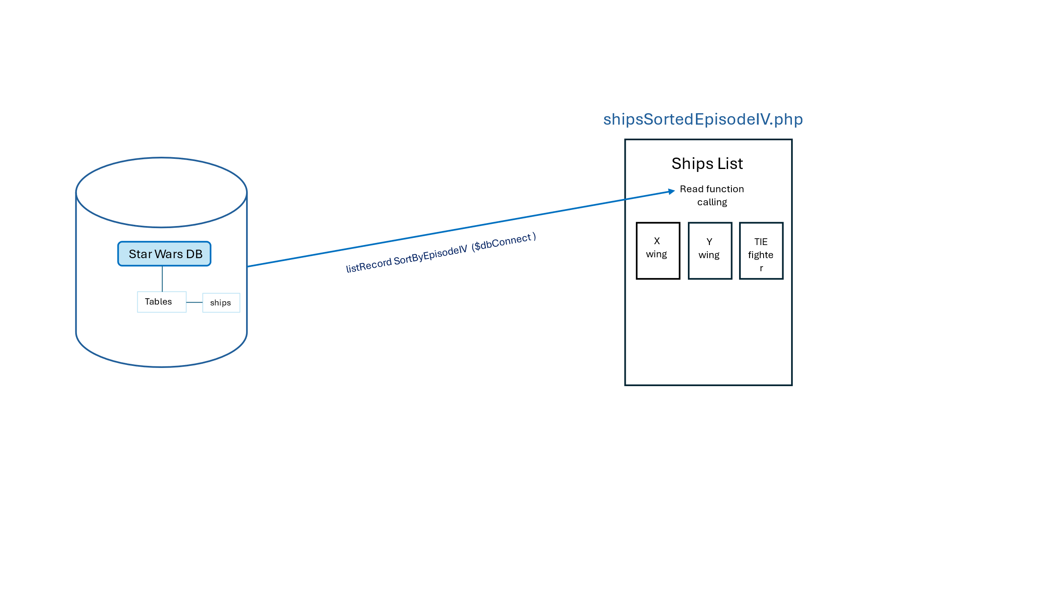

**Table**

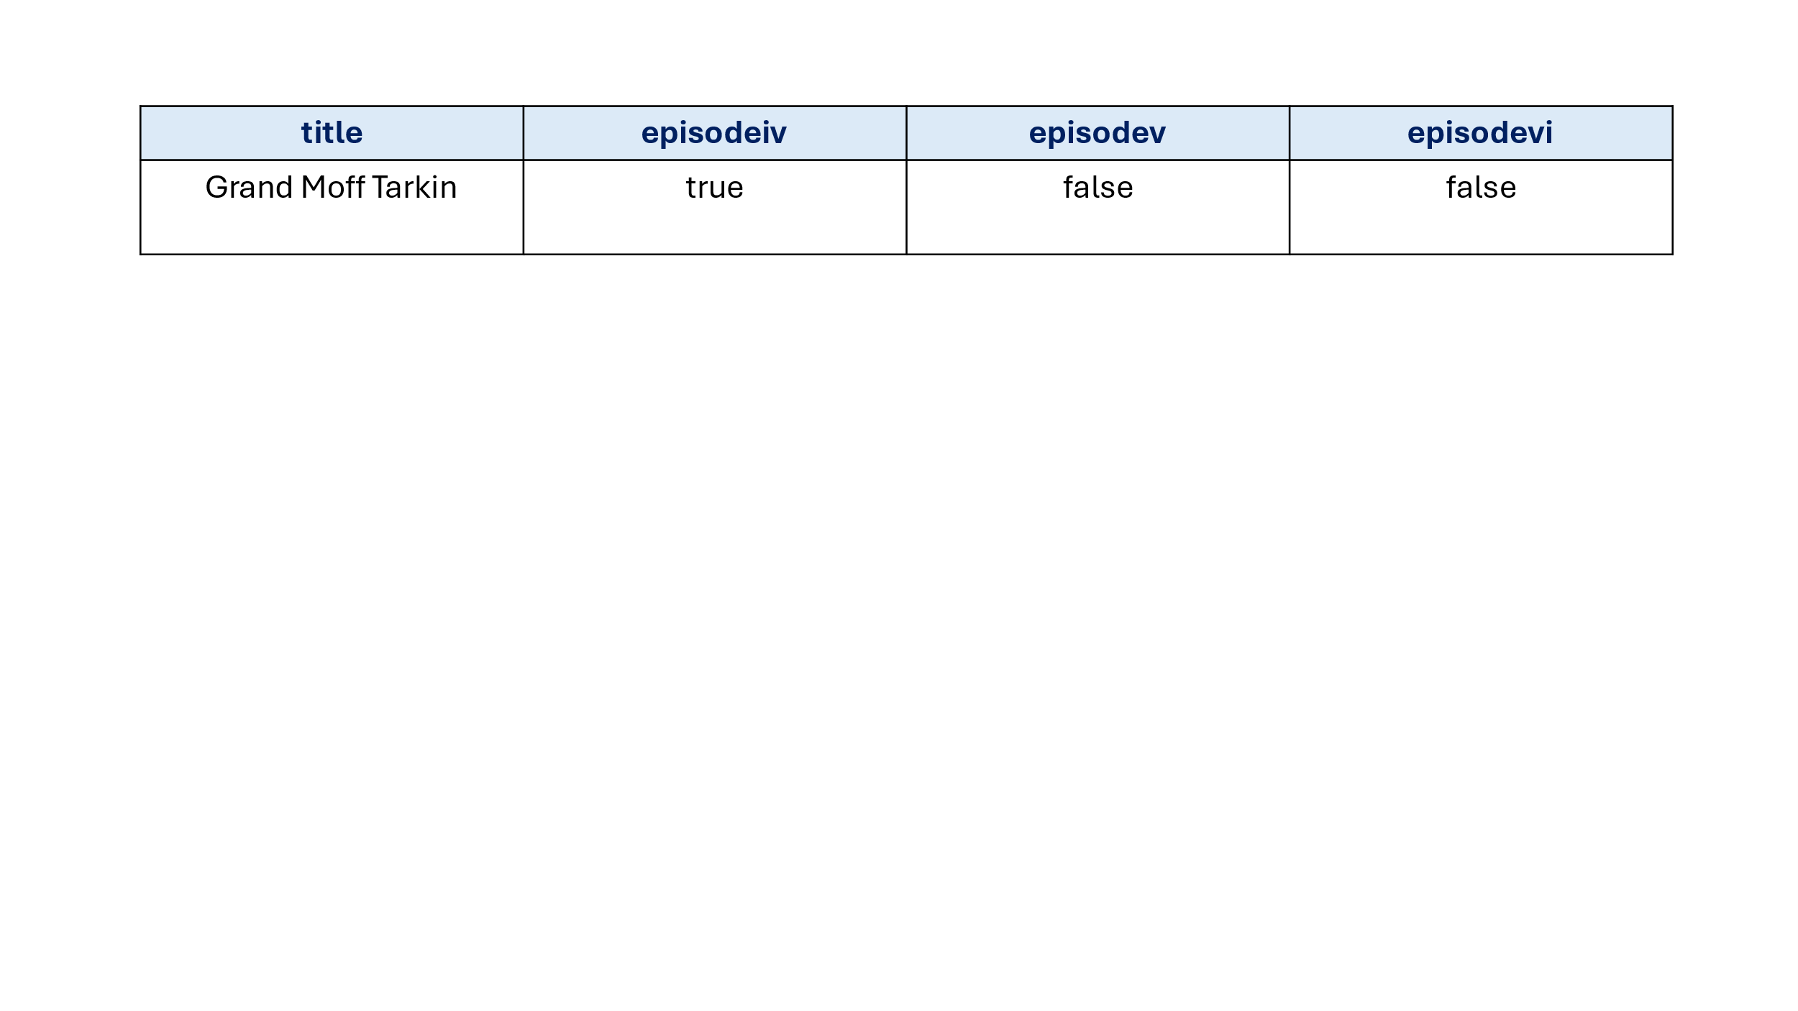

**Functions and Programming Control**

functions.php

When creating this data, the admin will need to mark a checkbox with the episodes in which the ship appears. To tackle the problem of sending empty variables to the table, a programming control needs to be implemented. So, if the POST memory is empty, it will automatically fill it with ‘false’

actionCreateShip.php

